|  |
| --- |
|  |
| MovieDbLite |
| Course Section: CS605.641  Spring, 2020 |
| Prepared by |
| **Anderson, Steven** |
| **04/22/2020** |



|  |
| --- |
| Database Design Project Document |

**Table of Contents**

1. Introduction 4

1.1. Scope and Purpose of Document 4

1.2. Project Objective 4

2. System Requirements 4

2.1 Hardware Requirements 4

2.2 Software Requirements 4

2.3 Functional Requirements 4

2.4 Database Requirements 4

3. Database Design Description 4

3.1 Design Rationale 4

3.2 E/R Model 4

3.2.1 Entities 5

3.2.2 Relationships 5

3.2.3 E/R Diagram 5

3.3 Relational Model 5

3.3.1 Data Dictionary 5

3.3.2 Integrity Rules 5

3.3.3 Operational Rules 5

3.3.4 Operations 5

3.4 Security 5

3.5 Database Backup and Recovery 5

3.6 Using Database Design or CASE Tool 6

3.7 Other Possible E/R Relationships 6

4. Implementation Description 6

4.1 Data Dictionary 6

4.2 Advanced Features 6

4.3 Queries 6

4.3.1 Customer Bills 6

4.3.2 Customer Rental History 6

4.3.3 Movie Rental History 6

4.3.4 List all videos by movie category 6

4.3.5 List video usage by movie category 6

4.3.6 List videos by format (Laser Disc or VHS) 6

4.3.7 List defective videos 7

4.3.8 List twenty popular videos by category for customers’ recommendations 7

5. CRUD Matrix 7

5.1 List of Entity Types 7

5.2 List of Functions 7

6. Concluding Remarks 7

Appendices 8

References 8

(Note: Please provide some inputs for the sections in your DB design document template even though some of them may not be suitable for your project. The purpose for all different sections is to ask you to think about different perspectives of a database project. If a section doesn't apply to your project, you should make something up. Please don't skip them.

For instance, Database Backup and Recovery is commonly implemented in a real database project. Even if you don’t implement it, most RDBMSs may have incorporated backup and recovery tools into their interfaces and infrastructure. Give a short description of your RDBMS solution to demonstrate your thought process.)

# Introduction

Movies are a common form of entertainment in the lives of many people. With the evolution of the internet and various streaming services, the access to films are more available than ever. The MovieDbLite project aims to be simple, easy-to-use website for viewing the details about movies and credits, as well as allowing users to rate and review the movies they have seen. In alignment with the website, the database itself is intended to be simple and intuitive for people with database experience.

For myself personally, I am a huge movie buff, and still go to the theaters multiple times a month with my wife to watch new releases. I chose this project because of my interest in movies and the people involved in delivering these films. In addition, the ownership of a movie database allows for me to personalize the reports or features that may not be found in other popular movie database applications. Furthermore, it opens up the possibility to create APIs (Application Programming Interfaces) for consumption of the data by other systems, use cases, and applications (e.g. trivia games).

## Scope and Purpose of Document

The purpose of this document is to describe design, development, requirement, and implementation details of the MovieDbLite database and website application, with the primary focus being on the database that is used to store movie and film industry data. Specifically, when it comes to the design of the database, the focus is on the conceptual and logical design and implementation. An existing, industry-standard Relational Database Management System (RDBMS) environment that handles the physical implementation of the database will be used. Therefore, lower-level details about physical storage and implementation of the database can be found via online resources of the respective RDBMS environment.

Overall, this document is bounded to describing the MovieDbLite database and front-end website for accessing basic details and reports of data within database. Accordingly, information about external applications that may consume the database data (e.g. through an API) is not intended to be covered by this document.

## Project Objective

The objective of this project is to design and implement a simple, yet useful movie database that tracks information related to the film industry. Further, the project intends to provide a front-end website to deliver an easy-to-use user interface for allowing users to view data and rate movies. This project shall be built using modern RDBMS and web-based technologies to captures the data elements and functional requirements that are mentioned in the upcoming sections. Ultimately, this database is intended to serve as a stable and maintainable back-end to enable future opportunities for APIs to be built for external applications to consume.

# System Requirements

The MovieDbLite is composed of three high-level system components that have their distinct set of system requirements:

1. The SQL Server hosted MovieDbLite Database
   1. Hosted on a remote server
2. The MovieDbLite Web Application Environment (Back-End)
   1. Hosted on a remote server
3. The MovieDbLite Website (Front-End)
   1. Accessed by an end-user via Web Browser

This section will cover the System Requirements (software and hardware) for the three major system components of the MovieDbLite system, as well as the functional requirements that make apart building these three components.

Although the Database (system component #1) and Web Application (system component #2) are hosted remotely, this does not necessarily mean they will be hosted on the same remote server/machine. In other words, the database and web application may be hosted on different server environments. Therefore, the following sections may distinguish and discretely separate the requirements for these respective components as appropriate.

## Hardware Requirements

This section describes the hardware requirements for the three components of the MovieDbLite system. In some of the hardware listings, a minimum hardware requirement is listed, as well as a recommended. The minimum hardware requirement is meant to indicate the minimum possible hardware specification to run or host the component. The recommended listing is the suggested minimum to mitigate deterioration of component performance. Overall, the system will support hardware specifications with larger amounts than the minimum/recommended listings, which would subsequently increase or maintain component performance and/or reliability.

### Database Server Requirements

The database server will require hardware able to host SQL Server Standard Edition 2017. The full server hardware requirements can be found in Microsoft’s documentation [here](https://docs.microsoft.com/en-us/sql/sql-server/install/hardware-and-software-requirements-for-installing-sql-server?view=sql-server-ver15#hardware-requirements).

This is the overall breakdown of the hardware requirements for SQL Server Standard Edition:

* **Memory** - Minimum of 1GB, recommended of 4GB
* **Hard Drive**
  + Computer with NTFS or ReFS file format for security reasons.
    - TODO: Provide links for NTFS and ReFS
  + Minimum of 6GB of available hard-disk space
    - Note: [Hard Disk Space Requirements](https://docs.microsoft.com/en-us/sql/sql-server/install/hardware-and-software-requirements-for-installing-sql-server?view=sql-server-ver15#HardDiskSpace) will apply depending on which components are installed
* **Monitor -** Super-VGA (800x600) or higher resolution monitor
* **Internet -** Internet access is required
* **Processor**
  + Speed: Minimum of 1.4GHz, recommended of 2.0+ GHz
  + Type: x64 Processor (e.g. AMD Opteron, AMD Athlon 64, Intel Xeon with Intel EM64T support, Intel Pentium IV with EM64T support)
* **Drive** – A DVD drive is required if installation is from disc

### Web Application Server Requirements

The Web Application environment (back-end to the website) will require an environment that can host an ASP.NET Website targeting .NET Core v3.1. The baseline hardware requirements can be found [here](https://help.syncfusion.com/aspnet-core/installation-and-upgrade/system-requirements#hardware-environment).

* **Memory** - Minimum of 512MB, recommended of 1GB
* **Hard Drive**
  + Up to 2GB of available space may be required
  + 300MB of free space is required in boot drive
* **Internet** – Internet access is required
* **Processor**
  + x86 and x64 processors are supported
  + Although specifications on speed is not provided, modern web servers recommend processor of 2.0+ GHz

### Website Front-End Access Requirements

The end-user will require hardware compatible to run a modern web browser (such as Chrome, FireFox, Edge) in order to access the website.

The following is the minimum hardware requirements for Chrome, which is generally the minimum requirements amongst other browser types:

* **Hard Drive** – Minimum 100MB of free hard drive space is required
* **Memory** – Minimum 128MB of RAM
* **Internet –** Network access is required to connect
* **Processor –** Pentium 4 and above
* **Keyboard (or equivalent) –** Typing will be required to perform searches
* **Mouse (or equivalent) –** Clicking will be required to navigate the web pages

More information can be found at this [link](https://d.docs.live.net/df1cecd6e646b923/Documents/Grad_School/Databases_605_641/Project/•%09https:/smallbusiness.chron.com/google-chrome-software-requirements-48820.html).

TODO: Android/iOS requirements?

TODO: Development environment requirements (Visual Studio and SSMS)

## Software Requirements

This section covers the software required to operate the components of MovieDbLite. In addition to Software application requirements, this section may list the Operating System (OS) requirements – as appropriate.

### Database Server Requirements

The database server will require software installed to host SQL Server Standard Edition 2017. The full server software requirements can be found in Microsoft’s documentation [here](https://docs.microsoft.com/en-us/sql/sql-server/install/hardware-and-software-requirements-for-installing-sql-server?view=sql-server-ver15#hwswr).

In summary, the following two software components are required to be installed on the server hosting the database:

1. .NET Framework (v4.6)
2. Network Software that support the following protocols: Shared Memory, Named Pipes, TCP/IP, and VIA.

The following [link](https://docs.microsoft.com/en-us/sql/sql-server/install/hardware-and-software-requirements-for-installing-sql-server?view=sql-server-ver15#operating-system-support) outlines the supported OS versions to host SQL Server 2017. Overall, the operating system must be a Windows Server 2012+ (2012, 2016, 2019) environment. Although Windows 8 and Windows 10 are listed as well, these are not intended to be used for remote hosting of the database.

### Web Application Server Requirements

The Web Application environment (back-end to the website) will require an Operation System environment that can host an ASP.NET Website targeting .NET Core v3.1. The full supported OS versions can be found [here](https://github.com/dotnet/core/blob/master/release-notes/3.1/3.1-supported-os.md). This section will focus on the remote server environments hosted by Windows, to remain consistent with Windows hosted database environment using SQL Server. In addition, the security model used for authentication to SQL Server will utilize Integrated Security which is Windows specific. More information on the connection string security is mentioned in section 3.4.3 Database Connection Strings

The following are the recommended operating system environments:

* Windows Server 2012 R2+
  + x64 and x86
* Windows Nano Server 1803+
  + x64 and ARM32

### Website Front-End Access Requirements

A modern web browser that supports HTML5 is required for the end-user to access the website.

The following are the preferred browsers to access the website:

* Google Chrome
* Microsoft Edge
* Mozilla Firefox
* Safari

Note: Although some features of the website may work in Internet Explorer, it is recommended to use one of the listed browsers above for full support.

## Functional Requirements

The MovieDbLite website will contain basic functionality to allow users to view details about movies and members of the film industry. Users may also create user accounts and rate/review movies. Administrative access will be available to allow for modification of movie and film industry details to keep the database’s data current.

This section covers the different functional requirements of the MovieDbLite web application in detail below.

* Track movie/film basic information (e.g. title, description, release date, duration, etc.)
  + Note: full data details to be described in Data Dictionary section. TODO: Link to this
* Track the different film members that are involved in the film industry, as well as basic information about them (preferred name, gender, date of birth, etc.)
* Track cast and crew members of a movie by their role (director, producer, actor, costume designer, choreographer, etc.)
* Track the different restriction ratings (e.g. G, PG, PG-13, R, etc.) that a film can be assigned to.
* Track the different international languages (English, Spanish, German, etc.) that a film can be assigned to.
* Track different annual award show events and the particular awards they give out
* Track the film members and movies that win awards at annual award show instances
* Track the different movie genres and allow movies to be classified as multiple of these genres
* Allow user to create a user account login (user name and password)
* Allow user access to modify details of their user account (user name, email address, password)
* Allow user to search for movies by movie title
* Allow user to perform an advanced movie search by other fields (description, release date, average user rating, restriction rating)
* Allow user to search for film members by their name
* Allow user to write a review and assign a user-rating (from 1-10) to a movie
* Allow user to mark a review as helpful or unhelpful
* Allow user to sort reviews by date, helpfulness, or rating
* Reports
  + Report a movie’s basic details (title, restriction rating, language, release date, etc.)
  + Report the film members (actors, producers, crew members, etc.) of a movie
  + Report the movies a film member has been a part of
  + Report the awards given to a certain movie
  + Report the awards given to a certain film member
  + Report the movies with the highest user rating
  + Report the user reviews for a movie
* Administratively allow adding/editing movie information
* Administratively allow adding/editing the film members of a movie
* Administratively allow inputting results from award show instances

## Database Requirements

The MovieDbLite Database is hosted using Microsoft’s SQL Server 2017 (Standard Edition).

The development/management environment used to perform DML and DDL operations against the database is Microsoft SQL Server Management Studio 17 (SSMS). The full details of SSMS are seen below.

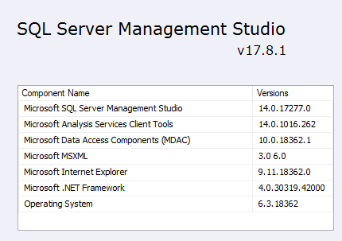

## Additional Development Details

The ASP.NET Core Web Application is Developed using the Visual Studio 2019 IDE. The programming languages are C#, JavaScript, HTML, and CSS using the MVC (Model-View-Controller) design pattern.



# Database Design Description

This database consists of a set of static and dynamic tables. Static tables can be defined as tables that are pre-defined and seeded with data upfront, and remain mostly static (meaning that the data in it is not added/modified/deleted often). The primary purpose of these tables is to avoid redundantly storing the names/descriptors for the values within other entities in the database (which may vary in length), where the value can simply be referenced by a static identifier. It also serves as a consistent/standard way of setting and viewing data in the database. For example, if these types did not exist, one may enter “Sci Fi” as a genre for a given movie, whereas another person may spell it out as “Science Fiction”. This would result in two different values being stored that mean the same thing.

The semantics about whether a table is static or dynamic is not too important, however, I chose to organize the following by it.

The static tables in the database, as well as their purpose, are as follows:

1. Award
   1. The purpose of this table is to track the different types of movie/film member awards that can be presented at annual award show events. Each award is tied to an Award Show. The Award contains a required AwardName column and optional Description.
   2. A Unique key/index constraint is added to the table for the combination of {AwardShowId, AwardName}. In other words, the AwardName should be unique for the given AwardShow. Consequently, this does also imply the AwardName by itself is not unique. For example, the Oscars and Critics’ Choice Awards both have an award named “Best Actress” (amongst other awards that also share the same names).
   3. This is considered a static table because (for the most part) the records in this table are not modified often, and have historically been fairly consistent on an annual basis when the award shows are hosted.
2. AwardShow
   1. The purpose of this table is to track the different types of annual movie/film award shows that present awards to movies/film members. The AwardShow contains a required ShowName column and optional Description.
   2. This is considered a static table because (for the most part) the records in this table are not modified often, and it is not often the case that Award Shows change. The standard ones have been around for a while (e.g. Oscars, Golden Globes, Critics’ Choice Awards, etc.)
3. FilmRole
   1. The purpose of this table is to track the different role types of the personnel/film members that contribute to making films/movies. A FilmRole contains a required RoleName column and optional Description.
   2. This is considered a static table because the records of this table will not be modified often, as the film roles in the industry have been well established over the years (e.g. Director, Writer, Producer, Actor, Costume Designer, etc.)
4. Genre
   1. The purpose of this table is to track the different genre types that movies can be classified by. A Genre contains a required GenreName and optional Description.
   2. This is considered a static table because the records of this table will not be modified often, as it is uncommon that new movie genres will be created. The existing movie genres have remained relatively unchanged for a while now (e.g. Action, Comedy, Horror, Romance, Drama, etc.)
5. Language
   1. The purpose of this table is to track the languages that the dialogue of a movie can be classified as. A Language contains a required Name column.
   2. This is considered a static table because the records of this table will not be modified often, as it is uncommon that new languages are created or established to be used in the film industry.
6. RestrictionRating

Dynamic

1. AwardShowInstance
   1. The purpose of this table is to keep track of each instance of an AwardShow. In other words, the actual award show event that takes place at a particular year. Each AwardShowInstance contains an Award Show it is in an instance of. It also contains a required Year field (the year the awards are being presented for) and DateHosted field (the Date the event instance took place).
   2. A Unique key/index constraint is added to the table for the combination of {AwardShowId, Year}. In other words, there should only be one instance of an AwardShow for a given Year. It has been the standard for a long time that these Award Shows are done on an annual basis, which is the reasoning behind the constraint.
   3. This table could borderline be considered static, however, multiple entries will be added to this on at least an annual basis, and for that reason, it can be classified as dynamic.
2. AwardWinner
   1. The purpose of this table is to keep track of the winners/recipients of Awards of a particular Award Show Instance. Each AwardWinner record tracks the AwardShowInstance it belongs to, the actual Award that was won, the Film Member it was presented to, and the Movie it was for. All of these columns are required.
   2. The combination of {AwardShowInstance, AwardId, FilmMemberId} make up the PK for the table. Multiple film members may be awarded a particular award (at an award show instance), and so this column must make up the unique primary key. For example, sometimes multiple people are awarded Best Costume Design or Best Cinematography for a particular movie.
   3. Both a FilmMember and a Movie are required to be entered for a record. This is because each Award that is presented is toward a particular Movie (there are currently not awards that exist otherwise, or at least are not tracked by this database). In addition, every Award is accepted/presented to a certain Film Member. This includes “Best Picture” award that may seemingly appear to be a “movie-only” award. However, the Producer(s) accept this award on behalf of the Movie.
3. FilmMember
   1. The purpose of this table is to track all the persons participating in the making of movies/films. This table tracks several fields for each FilmMember, including a Prefix (e.g. Dr., Mr., Mrs., Ms., etc.) (optional), FirstName (required), MiddleName (optional), LastName (required), Suffix (e.g. Jr., Sr., IV, etc.) (optional), PreferredFullName (required), Gender (M or F) (required), DateOfBirth (optional), DateOfDeath (optional), and Biography. The PreferredFullName field is an important field because this is what is intended to be used in most areas of the application to display the name of the FilmMember. This field is synonymous with “StageName”, and may differ from the person’s concatenated prefix/first/middle/last/suffix name. E.g. Katheryn Elizabeth Hudson goes by “Katy Perry”.
   2. An index (non-unique) is added to the PreferredFullName field as it will be common for searches to be performed against this field.
4. Movie
5. Movie_Genre
6. MovieCastMember
7. MovieCrewMember
8. MovieUserReview
9. MovieUserReviewHelpful
10. User

This database

* Track Annual Award Shows
* Track Different Awards
* Track Movies and Film Members that receive awards
* Track Movies
* Track what Language a Movie is in
* Track when a Movie is or will be released
* Track the Restriction Rating on a movie
* Track a Movie’s Genres
* Allow Users to Sign-Up for Site
* Allow Users to Review Movies
* Allow Users to mark other reviews as helpful/unhelpful
* Track Actors in Movies
* Track various Crew Members that work on the set of Movies

Standards:

1. Unique Key Constraints and Index Naming
2. Column Naming
   1. PascalCased
   2. Standard Column Naming
      1. {Blank}Name (Required)
      2. Description (Nullable)
3. Indexing Guidelines
   1. Natural Key on each table
4. Table Naming
   1. PascalCased
5. Identity Keys vs. Non-Identity Keys
6. Foreign Key Naming
7. Primary Key Naming
   1. Clustered
8. View Naming
9. Table Naming
10. Surrogate keys vs. non-surrogate
    1. If a table is being FK referenced, a surrogate key is used
11. Why Film vs Movie in some instances?

Assumptions:

1. Award Shows are annual

## Design Rationale

Why did you choose a particular ER design? Think about how your database design may be challenged and how you can defend your design. For example, did you use artificial primary keys and why? Why did you choose non-identifying relationship for two entities when it could be modeled as identifying relationship? Why?

## E/R Model

This section describes the E/R model for the database. The diagrams displayed were created using Visual Paradigm Community Edition, which is a useful tool for creating several types of diagrams (in addition to ERDs).

The following ERD is a diagram for the entire database and contains a Legend that explains the meaning for the visual icons/indicators. We will focus on four main components/portions of the overall diagram in this section, as these components encompass pieces of the primary functional requirements that can be individually explained.

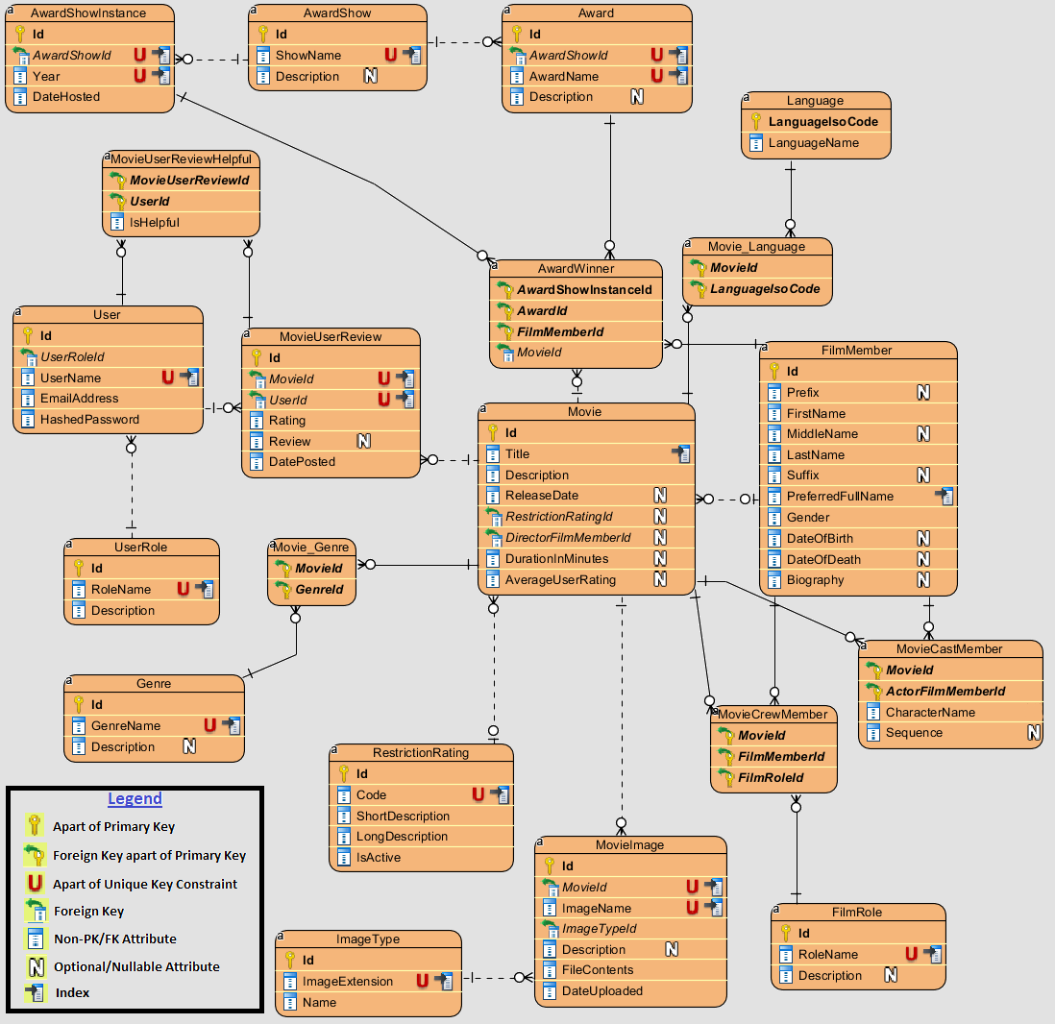

### General Movie Information

The diagram in this section illustrates how general movie information and details are stored in the database. The parent-most entity that contains Movie information in this relationship is the Movie entity. The Movie entity contains a number of attributes that are “one-to-one” relational with a Movie (e.g. Title, Description, Release Date, etc.) Many of the columns of the Movie entity are nullable because data for the Movie may be entered prior to the movie being released (e.g. in early stages when the Movie is announced). However, it is expected that these attributes are eventually filled in as the details are known.

Child entities are created off of Movie (such as MovieImage, Movie_Language, and Movie_Genre) to store additional details related to a Movie. Movie_Genre and Movie_Language are many-to-many intersection tables; MovieImage is a one-to-many table (a Movie may have many Images). Language, Genre, and ImageType are other Parent entities used by the respective Movie’s child entity tables.

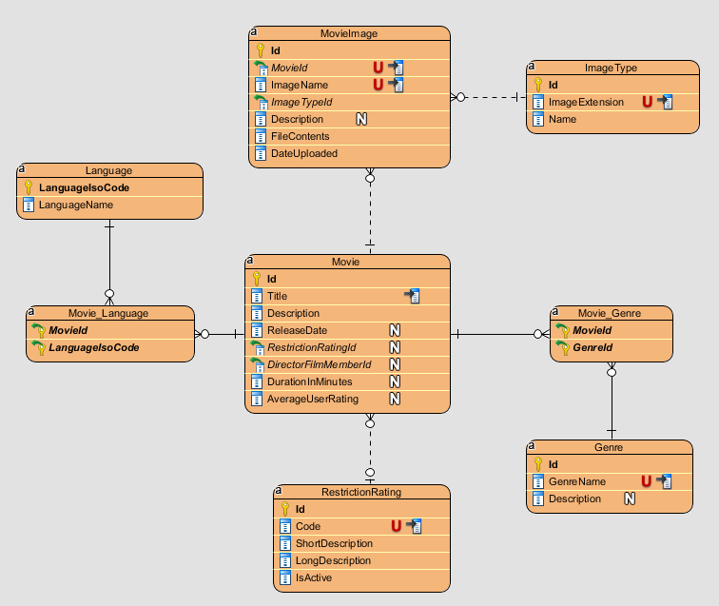

### User Access and Reviews

The diagram in this section illustrates how Users of MovieDbLite are stored, as well as how the ratings/reviews that user’s provide to Movies are stored. A User account can write a review for a Movie (stored in the MovieUserReview Entity), and other users can mark the Review as Helpful or Unhelpful (via MovieUserReviewHelpful). Each User is tied to a UserRole to indicate whether they are an Admin or regular User, which affects the permissions they have over certain areas of the application (although, both Users and Admins can write reviews for movies).

Note: Attributes from the Movie entity in the diagram below were removed for brevity. The important part was to show the relationship between MovieUserReviews and Movie.

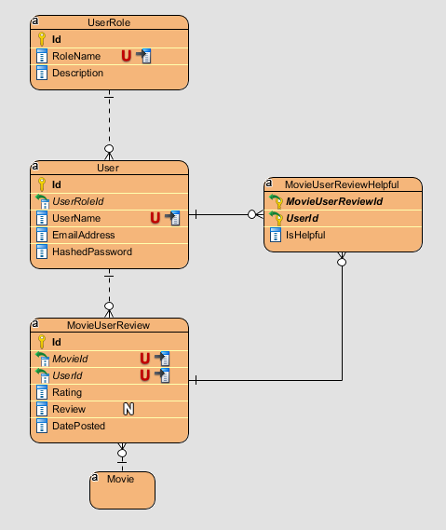

### Movie Cast and Crew

The diagram in this section illustrates how the cast and crew of a movie are stored. The FilmMember parent table stores all the persons/members of the film industry that participate as cast or crew members in a movie. The Movie table itself stores the DirectorFilmMemberId (as there can only be one director per movie). The MovieCastMember is used to store the cast members (i.e. actors) of a movie and associated information about them (e.g. their CharacterName).

The MovieCrewMember stores the crew members of a movie. The parent table FilmRole is used to describe what the crew member’s role is for the given movie (e.g. screenwriter, costumer designer, etc.)

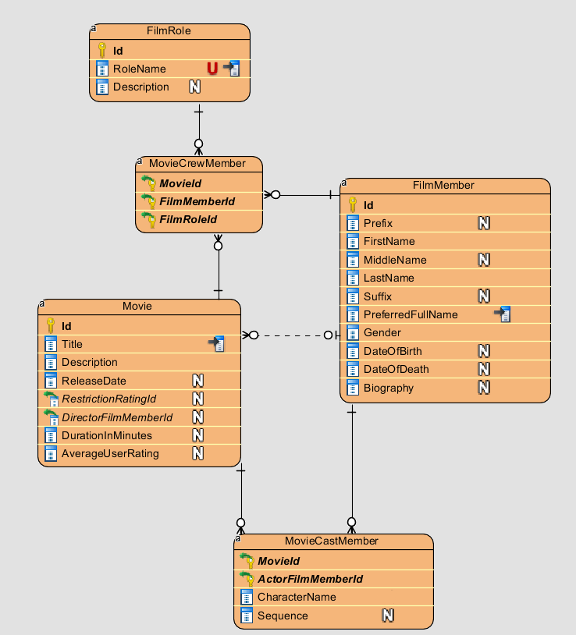

### Award Shows and Winners

The diagram in this section illustrates how the awards that are awarded for movies are stored. There are different types of AwardShows that have different types of Awards (every Award is associated with an AwardShow). The winners of awards are stored in the AwardWinner table. Each AwardWinner is associated with an AwardShowInstance, which is a parent entity that keeps track of annual award show events. An AwardWinner also is associated with a Movie that is associated with the award.

Note: Attributes from the Movie and FilmMember entity in the diagram below were removed for brevity. The important part was to show the relationship between AwardWinners and Movies / FilmMembers.

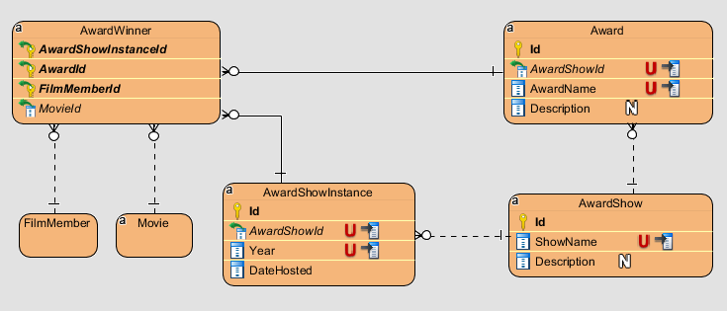

### Entities

Detailed descriptions of the entities

### Relationships

Detailed descriptions of the relationships

### E/R Diagram

E/R diagram

## Relational Model

### Data Dictionary

|  |  |  |  |  |  |  |
| --- | --- | --- | --- | --- | --- | --- |
| **Column Name** | **Description** | **Data Type** | **Size** | **Constraint Type** | **Not Null?** | **Valid Values** |
| Id | Award Id - Primary surrogate key | int |  | Primary Key | Y |  |
| AwardShowId | The award show that grants this award | smallint |  | Foreign Key Part of Unique Key | Y |  |
| AwardName | Name of the award (e.g. Best Actor) | varchar | 50 | Part of Unique Key | Y |  |
| Description | Description of award | varchar | 200 |  | N |  |
| Id | Award show Id - Primary surrogate key | smallint |  | Primary Key | Y |  |
| ShowName | Name of award show (e.g. Oscars) | varchar | 50 | Unique Key | Y |  |
| Description | Description of award show and its purpose | varchar | 200 |  | N |  |
| Id | Award show instance Id - Primary surrogate key | int |  | Primary Key | Y |  |
| AwardShowId | The award show that this is an instance of. | smallint |  | Foreign Key Part of Unique Key | Y |  |
| Year | The film year the awards are presented for (this is typically the year prior to the host date year) | smallint |  | Part of Unique Key | Y | 4 digit positive value |
| DateHosted | Date the award show instance takes or took place | date |  | Constraint Type | Y |  |
| AwardShowInstanceId | The award show instance the winner won an award from | int |  | Part of Primary Key Foreign Key | Y |  |
| AwardId | The award the winner won | int |  | Part of Primary Key Foreign Key | Y |  |
| FilmMemberId | The winner's film member Id | bigint |  | Part of Primary Key Foreign Key | Y |  |
| MovieId | The movie the award belongs to | bigint |  | Foreign Key | Y |  |
| Id | Film Member Id - Primary Surrogate Key | bigint |  | Primary Key | Y |  |
| Prefix | Optional prefix for name (e.g. Mr., Mrs., Dr., Prince, etc.) | varchar | 10 |  | N |  |
| FirstName | First name of film member | varchar | 50 |  | Y |  |
| MiddleName | Middle name of film member | varchar | 50 |  | N |  |
| LastName | Last name of film member | varchar | 50 |  | Y |  |
| Suffix | Optional suffix for film member (e.g. Jr, Sr., Jnr., Snr., III, IV). | varchar | 5 |  | N |  |
| PreferredFullName | The required preferred name for the film member, which is how they would like to be reported to others (e.g. Katy Perry instead of Katheryn Hudson) | varchar | 150 | Non-Clustered Index | Y |  |
| Gender | The film member's gender | char | 1 |  | Y | 'M' or 'F' |
| DateOfBirth | The film member's date of birth | date |  |  | N |  |
| DateOfDeath | The film member's date of death | date |  |  | N |  |
| Biography | A biography of variable length for the film member | varchar | max |  | N | No maximum length is specified. |
| Id | Film role id - primary surrogate key | smallint |  | Primary Key | Y |  |
| RoleName | The user-friendly role name for a film role (e.g. Actor, Producer, Costume Designer) | varchar | 50 | Unique Key | Y |  |
| Description | Description of the film role's purpose | varchar | 200 |  | N |  |
| Id | Genre Id - primary surrogate key | smallint |  | Primary Key | Y |  |
| GenreName | User-friendly genre name for a film (e.g. Action, Horror, Drama) | varchar | 25 | Unique Key | Y |  |
| Description | Description of the genre | varchar | 500 |  | N |  |
| Id | Image type id - primary surrogate key | int |  | Primary Key | Y |  |
| ImageExtension | File extension for the image (e.g. .jpg, .png) | varchar | 10 | Unique Key | Y | Extension starts with period |
| Name | Image type name (e.g. JPEG, PNG) | varchar | 25 |  | Y |  |
| LanguageIsoCode | ISO-639-1 code that is a standardized nomenclature used to classify languages (e.g. "en", "fr", "es") | char | 2 | Primary Key | Y | Two-letter code |
| LanguageName | User-friendly name for language (e.g. English, French, Spanish) | varchar | 50 |  | Y |  |
| Id | Movie id - primary surrogate key | bigint |  | Primary Key | Y |  |
| Title | The movie title name (e.g. Pulp Fiction) | varchar | 150 | Non-Clustered Index | Y |  |
| Description | A description of the movie that potentially costs of high-level plot details | varchar | 500 |  | Y |  |
| ReleaseDate | The scheduled or a actual release date for the movie | date |  |  | N |  |
| RestrictionRatingId | The restriction rating of the given movie | smallint |  | Foreign Key | N |  |
| DirectorFilmMemberId | The director for the movie | bigint |  | Foreign Key | N |  |
| DurationInMinutes | The duration of the movie, in minutes (e.g. 154) | int |  |  | N | An integer value that describes the movie length in minutes. |
| AverageUserRating | An average of all user ratings for the movie (e.g. 8.9) | decimal |  |  | N | A decimal value between 1.0-10.0 |
| MovieId | The movie id that is associated with the given genre | bigint |  | Part of Primary Key Foreign Key | Y |  |
| GenreId | The genre that is associated with the given movie | smallint |  | Part of Primary Key Foreign Key | Y |  |
| MovieId | The movie id that is associated with the given language. | bigint |  | Part of Primary Key Foreign Key | Y |  |
| LanguageIsoCode | The language id that is associated with the given movie. | char | 2 | Part of Primary Key Foreign Key | Y | Two-letter code |
| MovieId | The movie id that the cast member is a part of | bigint |  | Part of Primary Key Foreign Key | Y |  |
| ActorFilmMemberId | The actor/cast film member id | bigint |  | Part of Primary Key Foreign Key | Y |  |
| CharacterName | The actor's character name in the given movie (e.g. Tony Montana) | varchar | 150 |  | N |  |
| Sequence | A sequence number associated the movie cast member to order/rank the cast members of a given movie | int |  |  | N | A positive integer value. |
| MovieId | The movie id that the crew member is a part id. | bigint |  | Part of Primary Key Foreign Key | Y |  |
| FilmMemberId | The crew member's film member id. | bigint |  | Part of Primary Key Foreign Key | Y |  |
| FilmRoleId | The role that the film member participated in when making the movie. | smallint |  | Part of Primary Key Foreign Key | Y |  |
| Id | Move image id - primary surrogate key | bigint |  | Primary Key | Y |  |
| MovieId | The movie id that the image is associated with | bigint |  | Foreign Key Part of Unique Key | Y |  |
| ImageName | The user-friendly name given to the image | varchar | 100 | Part of Unique Key | Y |  |
| ImageTypeId | The image type (e.g. jpg, png) | int |  | Foreign Key | Y |  |
| Description | Description of the image | varchar | 500 |  | N |  |
| FileContents | The actual raw binary contents of the image | varbinary | max |  | Y | Raw binary contents of the file |
| DateUploaded | The date the image was uploaded | datetime2 |  |  | Y |  |
| Id | Movie user review id - primary surrogate key | bigint |  | Primary Key | Y |  |
| MovieId | The movie the review is associated with | bigint |  | Foreign Key Part of Unique Key | Y |  |
| UserId | The user that wrote the review | int |  | Foreign Key Part of Unique Key | Y |  |
| Rating | The rating the user wrote for the review (e.g. 8) | smallint |  |  | Y | An integer value from 1-10 |
| Review | The optional review text that the user wrote | varchar | 8000 |  | N |  |
| DatePosted | The date the review was posted | datetime2 |  |  | Y |  |
| MovieUserReviewId | The movie user review that was deemed helpful. | bigint |  | Part of Primary Key Foreign Key | Y |  |
| UserId | The user that marked the review helpful | int |  | Part of Primary Key | Y |  |
| IsHelpful | Whether the review was actually helpful or unhelpful, respective of the bit field | bit |  |  | Y |  |
| Id | Restriction rating id - primary surrogate key | smallint |  | Primary Key | Y |  |
| Code | The MPAA restriction rating that can be assigned to a movie (e.g. PG-13) | varchar | 10 | Unique Key | Y | A valid MPAA film rating code (G, PG, PG-13, R, etc.) |
| ShortDescription | A short description of the rating (e.g. "General Audiences") | varchar | 50 |  | Y |  |
| LongDescription | A more detailed description of the rating | varchar | 200 |  | Y |  |
| IsActive | An active flag for whether or not the rating is still used. Certain ratings (e.g. "M") are no longer used. | bit |  |  | Y |  |
| Id | User Id - Primary surrogate key | int |  | Primary Key | Y |  |
| UserRoleId | The user's role for the MovieDbLite application | smallint |  | Foreign Key | Y |  |
| UserName | A username/handle chosen by the user (e.g. stevo9510) | varchar | 25 | Unique Key | Y | Letters and numbers only (no special characters) |
| EmailAddress | The user's email address | varchar | 255 |  | Y | Must be in a valid email format. |
| HashedPassword | The user's password secured with a bcrypt hash | varchar | 60 |  | Y | The password must contain a capital letter, lowercase letter, number, and be 10 or more characters. The password is a bcrypt hashed value (up to 60 chars) |
| Id | User role id - primary surrogate key | smallint |  | Primary Key | Y |  |
| RoleName | The role name for the role (e.g. Admin, User, etc.) | varchar | 25 | Unique Key | Y |  |
| Description | A description of the role and its general permissions | varchar | 500 |  | Y |  |

### Integrity Rules

How did you handle the mandatory fields, data formatting/conversion, and valid values for the data? How are the referential integrity established? For example, which table references which other table?

### Operational Rules

What are the constraints for some operations? For example, will the users be able to delete a patron’s information if he/she has outstanding videos? Can a patron be associated multiple records of checked-out videos? Will the application allow the users to enter a patron if the patron has the same first name and last name as an existing patron in the system?

* UserName constraints

### Operations

Describe what operations are involved for a particular use case. For example, does checking out videos involve insert/delete/update/retrieve?

## Security

This section covers the security provisions taken by MovieDbLite to ensure security of data and user operations within the system.

### 3.4.1. Password Storage

Users have the ability to create user accounts to rate and review movies that they have watched. User accounts require a username, email, and password. The password is transmitted over the network using HTTPS (see upcoming section), and is never stored as a plaintext in the database. Instead, a **hashed** version of the password is stored in the database. Hash functions are useful because they cannot be algorithmically reversed back to plaintext.

When the user attempts to authenticate/login to the system, the typed/entered password is transmitted to the server (via HTTPS) and hashed using the same algorithm that was used to store the password in the database. The hashed entered/typed password is then compared against the hashed value in the database to see if they match, and if so, the user has successfully authenticated.

The hash algorithm used is [BCrypt](https://en.wikipedia.org/wiki/Bcrypt), implemented by the BCrypt.Net-Core package/library available in Microsoft’s NuGet Package Repository. BCrypt is a modern hashing algorithm that uses a salt/work factor to mitigate against [rainbow table](https://en.wikipedia.org/wiki/Rainbow_table) attacks (i.e. precomputed hash tables for reverse engineering hashes). It is a recommend password hashing algorithm by many sources, including this [one](https://auth0.com/blog/hashing-in-action-understanding-bcrypt/) on the Auth0 website.

The following is a snippet of the BCrypt library in use for MovieDbLite. This example shows a method that takes the unhashed (plaintext) password, and then returns the hashed version of it using BCrypt and a work factor/salt of 15.



* Note that we would normally not want to share the work factor/salt or make it known to others (for security reasons), however, for the intentions of this project I wanted to show how it worked with a real value.

### SQL Injection

MovieDbLite prevents SQL Injection attacks through the use of reliable .NET framework libraries and tools, such as ADO.NET and Entity Framework ORM (Object Relational Mapping) functionality.

ADO.NET contains [SqlCommand](https://docs.microsoft.com/en-us/dotnet/api/system.data.sqlclient.sqlcommand?view=netframework-4.8) and [SqlParameter](https://docs.microsoft.com/en-us/dotnet/api/system.data.sqlclient.sqlparameter?view=netframework-4.8) classes that prevent SQL Injection attacks by parameterizing any arguments to pass to a stored procedure. When these classes are used for a SQL Server database connection, they [abstract](https://stackoverflow.com/a/4892205) away functionality to call into the sp_executesql system-level stored procedure in SQL Server, which isolates the parameters and treats them as data.

Here is an example of usage of these libraries in the MovieDbLite web application to insert an award winner (via the usp_InsertAwardWinner stored procedure).

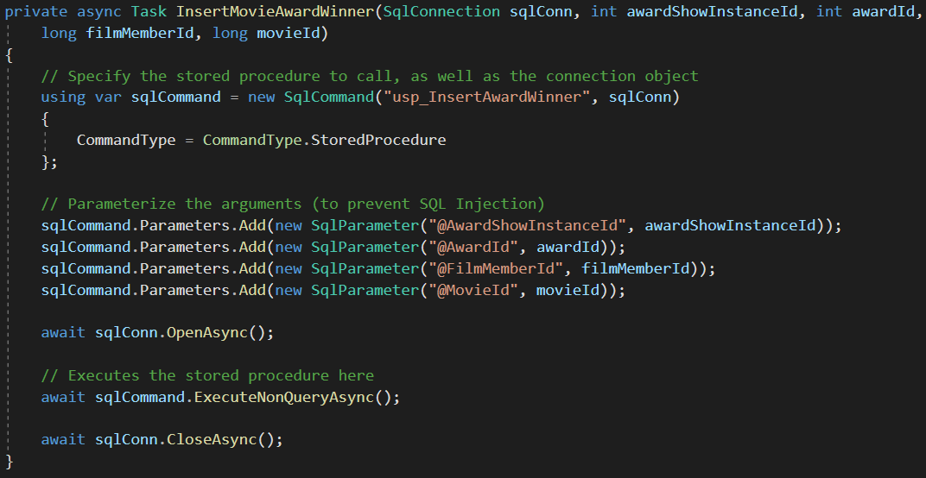

Additionally, other operations in MovieDbLite utilize the Entity Framework ORM technology to perform CRUD. Entity framework is built with SQL injection protection by way of using its functions, allowing the developer to not have to put too much effort in mitigating the risk. The example below shows how an AwardShowInstance is added in MovieDbLite utilizing Entity Framework’s DbContext object (see MovieDbLiteContext _context). The new instance is added to the database by simply adding it to the context’s collection (via Add method), and then calling SaveChangesAsync() against the context. No raw SQL is used in this operation, and consequently there is no SQL injection risk.

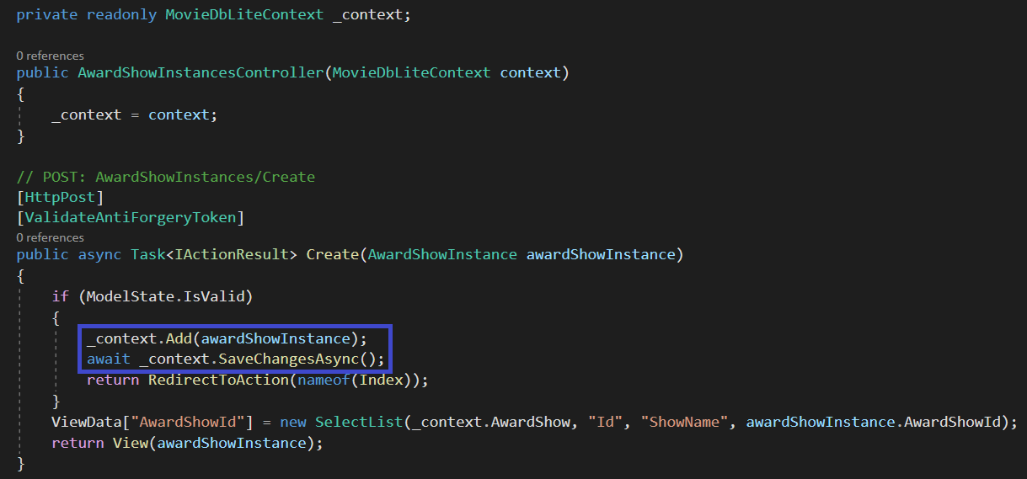

### Database Connection Strings

The database connection string for SQL Server utilizes Windows Authentication, also known as Integrated Security (SSPI). This security model is tightly integrated with Windows user and group accounts that are assigned and allowed to access the database.

The primary advantage of this security model is that there is no password management involved, and subsequently, no need to store SQL authentication user and password for the application. Instead, the application authenticates via secure, underlying Windows OS functionality based on the user account that is attempting to access the database. The user account groups that are granted access to the database are managed by administrators and permissions to the database will be limited. Further, groups can be assigned to particular SQL Server [Database-Level Roles](https://docs.microsoft.com/en-us/sql/relational-databases/security/authentication-access/database-level-roles?view=sql-server-ver15) which can limit the access the group member has to database object. For example, a group can be setup such that they have read-only access to the database, whereas another group can be setup to have full read/write access to the database.

For the deployed web application that requires access to the database, the Web Server’s Application Pool User (the proxy user that the web application runs on behalf of) will be granted read/write access to the database tables. Additionally, the App Pool user will be restricted from making any DDL changes (e.g. dropping tables, altering columns, etc.) because all of that should be performed by a DBA with allowed permissions.

Generally, Windows Authentication is a recommended authentication technique for SQL Server if it can be supported. More information about it can be found [here](https://docs.microsoft.com/en-us/dotnet/framework/data/adonet/sql/authentication-in-sql-server).

This is an example of the connection string for a Windows Authentication / SSPI based connection. Notice that there is no user name or password specified, as would be if it used a traditional SQL Authentication connection.



### Network Connection

The Website is hosted using HTTPS secure communication protocol over a computer network. This method of communication encrypts the network data while in-transit between the client and the server, preventing “man-in-the-middle” attacks.

## Database Backup and Recovery

### Automated Database Backups

A backup of the MovieDbLite database will be performed on a nightly basis, and output to the database server and a secondary archive server environment (to achieve some redundancy of the data in the event of a database server failure). These backups will be kept for at least 6 months in the event that recovery of the database is necessary. SQL Server has the ability to schedule automatic backups of the database via the SQL Server Agent Jobs function, as seen [here](https://www.sqlshack.com/multiple-methods-for-scheduling-a-sql-server-backup-automatically/).

Here is an example of a SQL script used to perform database backups for MovieDbLite. It timestamps the backup with the date to ensure no collisions with other backups, as well as identifying when the backup took place.

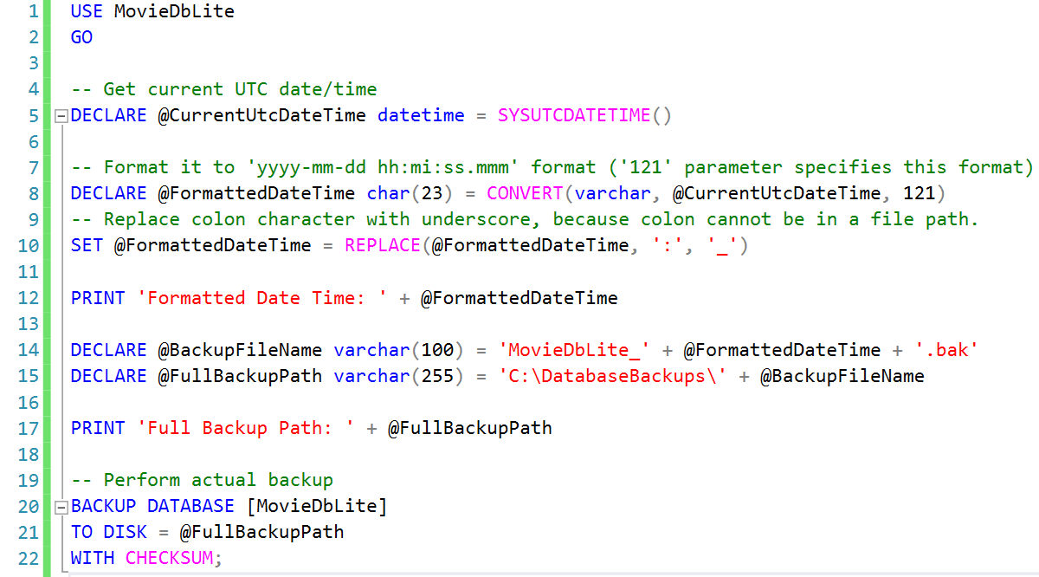

Output from backup:

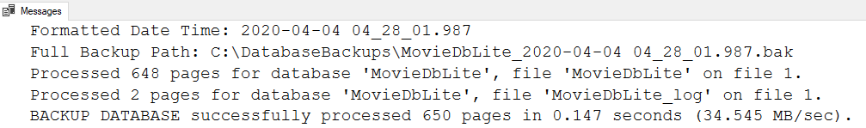

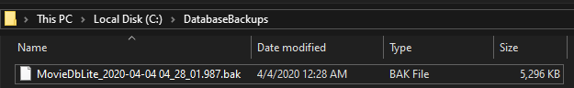

### Full Database Recovery Model

The [recovery model](https://docs.microsoft.com/en-us/sql/relational-databases/backup-restore/recovery-models-sql-server?view=sql-server-ver15#RMov) for the database will be set to **Full**. This allows the database to be restored to an arbitrary point of time (e.g. before an error occurred) if that is necessary. The Full recovery model relies on transaction log files of the database to be created and stored. [Backups](https://docs.microsoft.com/en-us/sql/relational-databases/backup-restore/transaction-log-backups-sql-server?view=sql-server-ver15#LogBackupSequence) of the transaction log files will also be required by the DBA, otherwise the log files will grow forever. The backup process for a transaction log file is a similar process to the aforementioned process of backing up a database.

This is an example of how to set the Recovery Model to Full via the Database’s properties using SSMS.

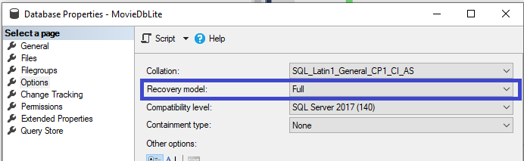

### Source Control of Database and Application

## Using Database Design or CASE Tool

Software engineering tools provide automated or semiautomatic support for software development. A CASE (Computer-Aided Software Engineering) tool sometimes is more important than hardware for achieving good quality and productivity. Describe the tools you used to produce the artifacts for your project.

## Other Possible E/R Relationships

What were the other alternatives you considered when you designed your database?

# Implementation Description

General implementation requirements

## Data Dictionary

Data dictionary after you have your database set up. This dictionary is less detailed than the one in the previous section. Usually, a “DESCRIBE” operation in your database will provide the information needed for this section. If your RDBMS has a tool to show data dictionary; it is also fine too.

## Advanced Features

Describe any triggers, stored procedures, functions, or others used in the project to implement business rules specified in your database project; (You may include user interfaces with screen shots if you have implemented a database application).

## Queries

General query information (Your specific database queries or reports)

### Customer Bills

How did you query customer bills? Provide SQL statements.

### Customer Rental History

Same as above.

### Movie Rental History

Same as above.

### List all videos by movie category

Same as above.

### List video usage by movie category

Same as above

### List videos by format (Laser Disc or VHS)

Same as above.

### List defective videos

Same as above

### List twenty popular videos by category for customers’ recommendations

Same as above

# CRUD Matrix

CRUD matrix as described in one presentation by Dr. Kung

## List of Entity Types

## List of Functions

# Concluding Remarks

Lessons learned and strengths and weaknesses, what you may add to the database project if you have more time.

More data fields.

1. AwardShowInstance could have a location column
2. Track Production companies
3. File Attachments
4. Future - Store Nominations
5. Add remaining award types
6. Add data from other systems

Appendices

Additional information, such as known defects

Appendix A - DDL, INSERT, SELECT Statements

CREATE statements for creating database objects; INSERT statements to populate test data into the database; SELECT statements to display the test data

Appendix B - Data Dictionary Index

Index to the data dictionary (e.g., column_name in alphabetical order, table_name))

References

Reference material